Moving detection and emails
Step 1: open the desk menu by right-click → main menu → set up → Alarm → Motion
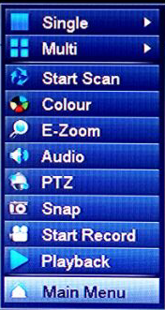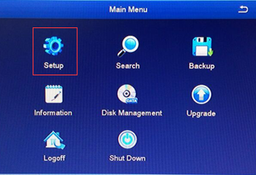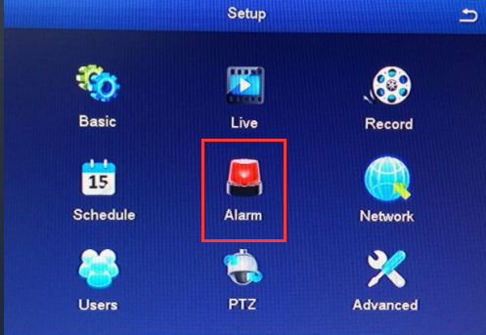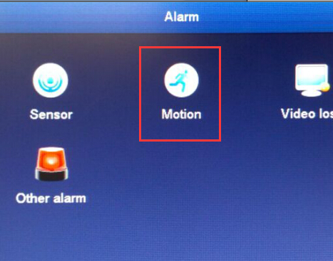
Step 2: enable the motion function
Step 3: set up the trigger, click the “settings”
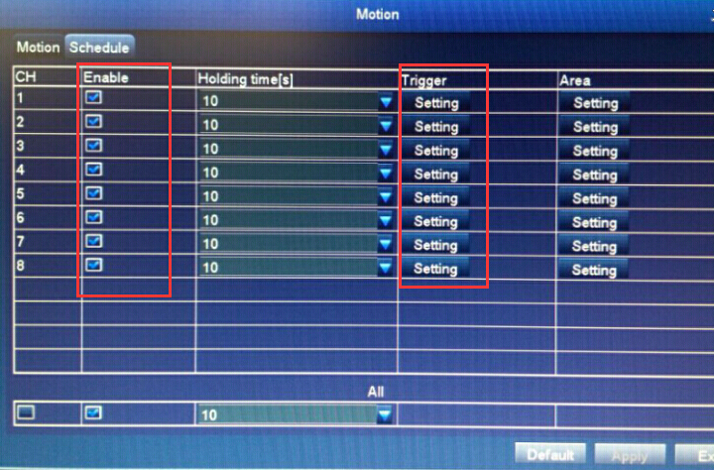
Step 4: Click the email in “alarm” window and enable all channel “Snap”
Then click “OK” button to save settings.
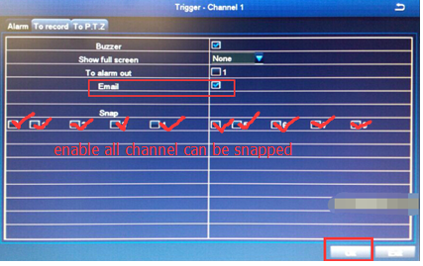

Step 5: set the motion Area, click the settings
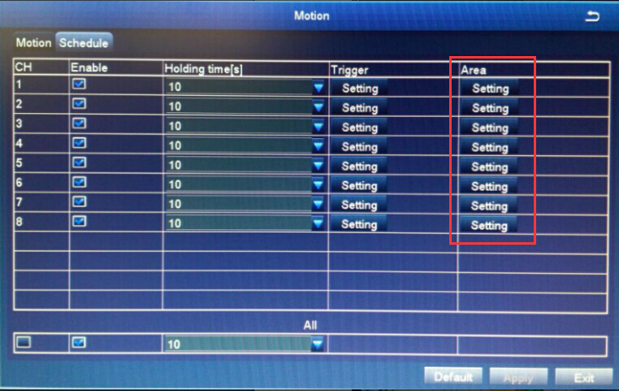
Step 6: choose the motion area you want, click and drag the mouse, the screen with block is the motion area you want
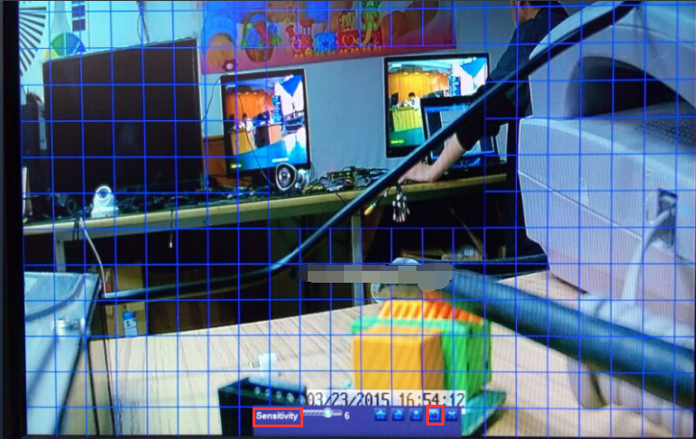
Step 8: right- click → adjust Sensitivity ( remark: the number smaller, the sensitivity higher) → click “save”
Step 9: click “Apply” bottom to save the motion settings
Step 10: click the “Exit” button into “setup” window
Step 11: click the “network” into network settings
Step 12: choose the email menu
Step 13: set the send email smtp server
Step 14: tick the SSL cheek
Step 15: set the send email address
Step 16: set the send email password
Step 17: set the receive email address
Step 18: click “Test”button for Test settings
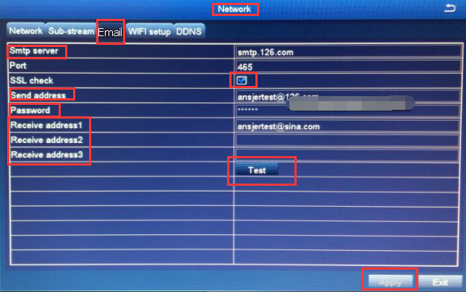
Step 19: The test result will be displayed in warning window
Step 20: click “ok” bottom to exit
Step 21: click “exit “to exit network window
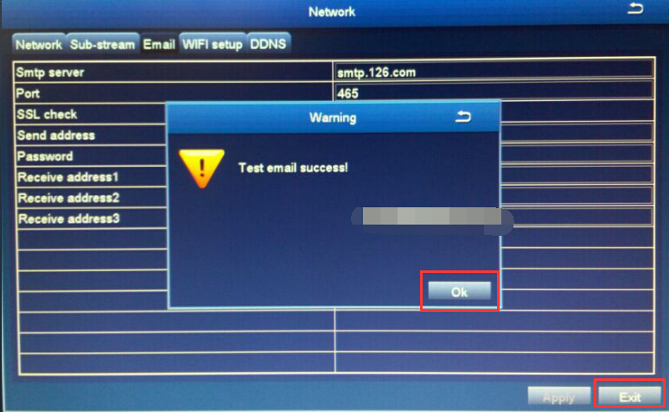
Remark: you will receive the alarm email if the motion alarm done

Email setting:
Please follow up the below link to set up the email notification:
https://support.zositech.com/hc/en-us/articles/115004611987-How-to-use-a-new-Gmail-account-to-set-DVR-mail-alarming-

