**Moving detection and emails**

Step 1: open the desk menu by right-click → main menu → set up → Alarm → Motion

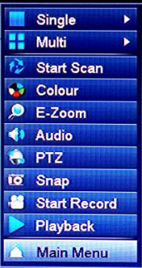 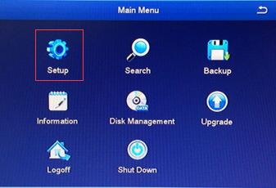 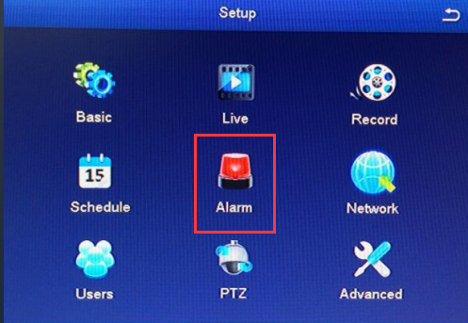 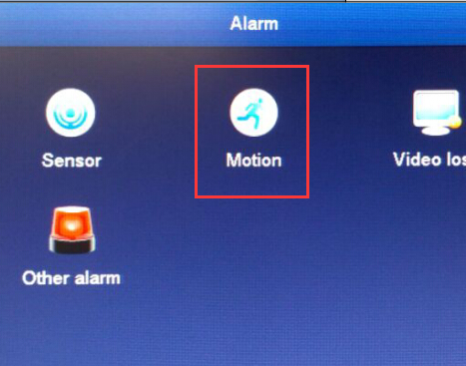

Step 2: enable the motion function

Step 3: set up the trigger, click the “settings”

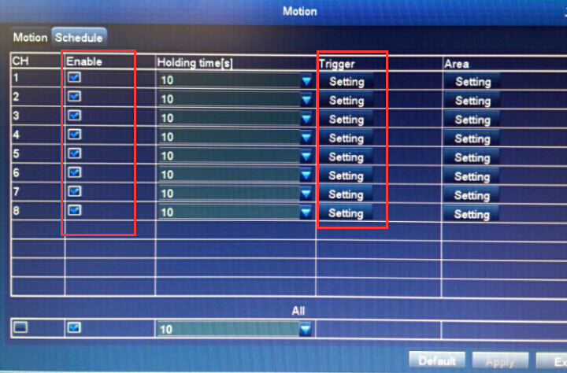

Step 4: Click the email in “alarm” window and enable all channel “Snap”

Then click “OK” button to save settings.

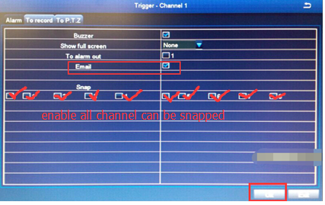

Step 5: set the motion Area, click the settings

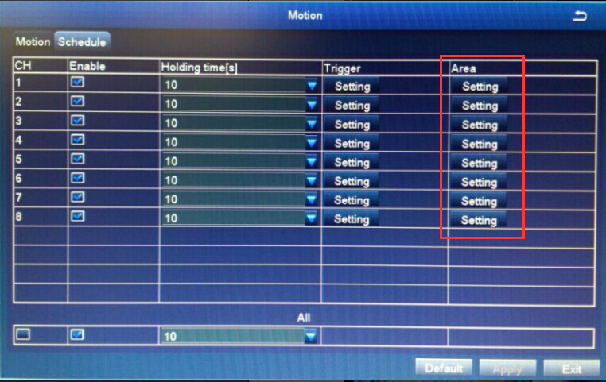

Step 6: choose the motion area you want, click and drag the mouse, the screen with block is the motion area you want

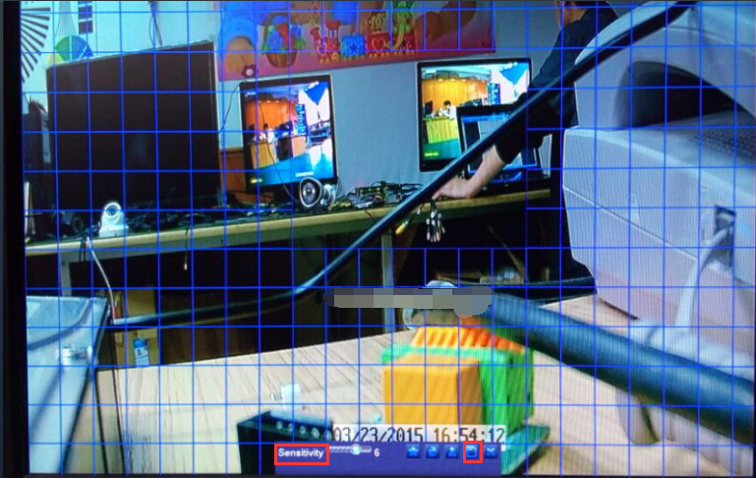

Step 8: right- click → adjust Sensitivity ( remark: the number smaller, the sensitivity higher) → click “save”

Step 9: click “Apply” bottom to save the motion settings

Step 10: click the “Exit” button into “setup” window

Step 11: click the “network” into network settings

Step 12: choose the email menu

Step 13: set the send email smtp server

Step 14: tick the SSL cheek

Step 15: set the send email address

Step 16: set the send email password

Step 17: set the receive email address

Step 18: click “Test”button for Test settings

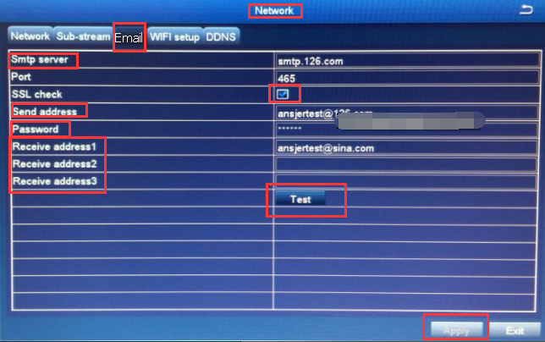

Step 19: The test result will be displayed in warning window

Step 20: click “ok” bottom to exit

Step 21: click “exit “to exit network window

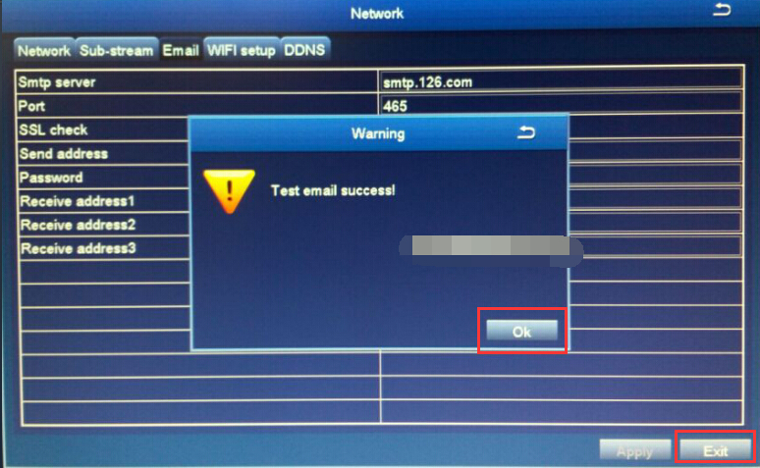

Remark: you will receive the alarm email if the motion alarm done

**Email setting:**

Please follow up the below link to set up the email notification:

https://support.zositech.com/hc/en-us/articles/115004611987-How-to-use-a-new-Gmail-account-to-set-DVR-mail-alarming-