1.Search Tool

1.1 Download the “Search Tool” from ZOSI Help Center https://support.zositech.com/hc/en-us/articles/360006588932-Search-Tool-for-IP-Camera- . Install the “Search Tool.exe” on the computer. Double click to open it and the interface is shown below:

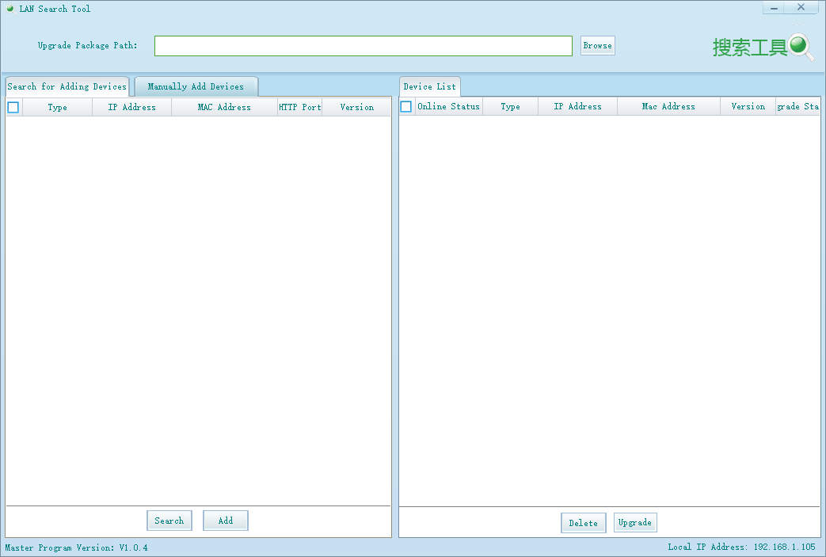
1.2 Modify the IP address of the camera.
1.2.1 Click “Search” button for searching the IP address of the camera.
1.2.2 Select the corresponding device and right click; then click “network configuration” for next step.
1.2.3 IP address of the camera needs to be modified to ensure that the network segment of the camera is in line with that of the router (computer), but both addresses should not be the same so as to avoid conflicts between the two IP addresses.
Note: Take the IP address “192.168.1.108” for example. “192.168.1” is the internet segment which must remain consistent between the two devices. The last three characters “108” is the IP. IP of the two devices (camera and computer/router) should not be the same.
1.2.4 Input the new IP address and click “settings” for confirmation.
After finishing all these steps, click “Search” button again and wait for 1-2 minutes to complete the setting. The completed interface is shown below.
